6th Form Shadowing Project
Medicine and the multi-disciplinary team
This programme has been developed and led by Dr Paul Laboi, Consultant Physician in renal medicine, York Hospital. It is supported by colleagues across the NHS Trust and Hull York Medical School. Everyone involved gives their time willingly to encourage students from state schools to enter medical school. It gives a clear understanding of the wide range of skills needed for a career in medicine and of the partnerships that exist in the multi-disciplinary team.


The programme is funded and supported by the Friends of York Hospitals, a Registered Charity, which raises funds to improve the experience of patients within York Hospitals. In 2024 The Friends of Selby Hospital are supporting students from Selby College.

Attendance will enhance personal statements of students and help them prepare for medical school interviews by increasing insight into the profession and equipping them with relevant skills and experiences highly valuable in aspiring medical applicants.

Schools involved in the project are: Fulford, All Saints, Archbishop Holgate, York College, Joseph Rowntree, Huntington School, Selby College, Woldgate School, Outwood Academy, Malton, Norton College and Lady Lumley’s
What is it?

An opportunity for students interested in a career in medicine, to gain some understanding of the field of medicine and the working of the multi-disciplinary team by:

Talking to consultant medical staff and GPs, about the role of the doctor in various specialties such as renal medicine, radiology, gastroenterology, surgery and general practice

Learning from members of the multi-disciplinary team, including pharmacists, dieticians, psychologists and specialist nurses about how they fit into the team caring for patients.

Meeting patients and their carers to gain insight into the patient experience. This may include the complicated world of transplantations, dialysis and long-term care for chronic illnesses such as cystic fibrosis.
Debating the wider influences on healthcare such as ethics in and balancing financial budgets in the light of the competing demands.

Participating in a session about how research improves treatment for patients

Understanding what medical schools are looking for, how to complete an application form and learn interview techniques.

When?

The programme will run on Wednesday afternoons for 9 weeks from 17 January to 20 March 202 in the Learning and Resource Centre at York Hospital.

Eligibility

There are 25 places on the programme. Students must be in year 12 and be attending a state 6th form school/college. They must commit to attending all nine sessions.

Application process

Invitations to apply are sent out to the 6th Form Tutors of the local schools/college in November of each year with details of the application process or an application form can be downloaded from https://foyh.org.uk/6th-form-shadowing-project/

The closing date for applications for the 2024 programme is
14 December 2023

Further information can be sought from Stephanie Neale on Stephanie.neale1@nhs.net

29/10/23

Feedback from previous students

“I just wanted to thank you for this incredible experience. I’ve learnt so much from the sessions, and have thoroughly enjoyed every minute. It was brilliant to speak to doctors in a wide range of specialities, enabling me to gain a deeper understanding into what it’s like to work for the NHS, and learn more about the role of a doctor. I’m also grateful for the opportunity to speak to other healthcare professionals, which has given me valuable insight into the multidisciplinary team. I feel I have benefited hugely from talking to patients, as it allowed us to view life from their perspective and see the challenges they face on a day to day basis. This experience has made me even more enthusiastic about becoming a doctor!”
“I enjoyed the project, and would definitely recommend it to anyone considering a career in medicine. I especially enjoyed speaking to patients and learning about how their specific treatment for the same disease varied slightly from patient to patient. It reminded me of the difference between treating disease and treating patients, which I believe is hugely important in medicine, and I hope will help me to provide quality care throughout my own career.”

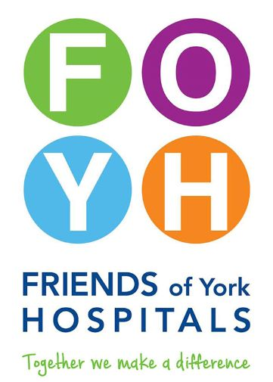 | 