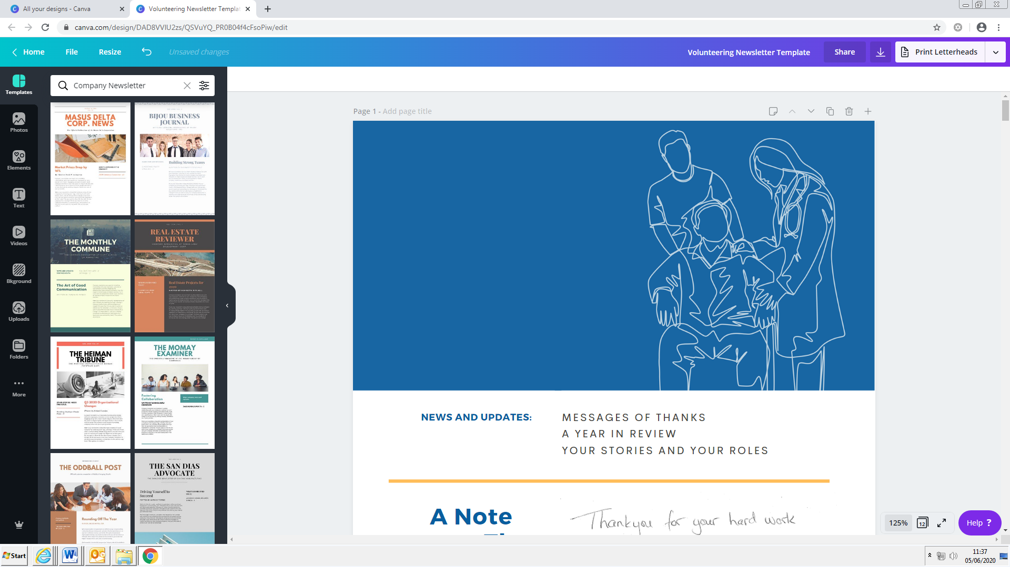
Ward Support Volunteer
Role Description
Tasks:
- Liaise with staff at each session to check patient requirements
- Encourage patients identified to you to eat and drink, and remind the patient if they have not finished their food
- Assist patients with cutting food and opening packets, and assist with patient dignity.
- Assist with feeding patients that would not otherwise be able to feed themselves.
- Refresh patient water jugs as necessary (after checking with the nursing staff).
- Liaise with staff to identify appropriate patients who would benefit from activities.
- Deliver agreed activities, either with an individual patient or a number of patients.
- Answer phone calls on any of the ward phones and take messages or proactively ring family members with patient updates.
- Ask patients if they would like to use the iPad to video call patients families, and facilitate this.
- Transferring bags from main reception to the ward
- Help seek patient and carer feedback using paper or online questionnaires, and one-to-one discussions.
- Collect Friends and Family Test cards and help patients to complete them.

Volunteers Should Not:
- Provide assistance for any patients on texture modified diets (including thickened fluids etc)
- Complete any personal care tasks such as toileting.
- Assist with moving and handling tasks (volunteers can push a wheelchair if a patient can transfer in/out of the wheelchair independently).
- Access patient medical notes, complete food chart/patient documentation.

We will support you by:
- Providing and delivering a mandatory training program
- Providing the necessary PPE for the role.
- Providing access to other training as appropriate
- Linking you with a volunteer supervisor who will be your main point of contact, as well as the Volunteer Services team.
- Listening to your feedback about your role
- Reimbursing reasonable travel expenses incurred as a result of volunteering (see Volunteering Expenses policy)

The Trust requires all volunteers to demonstrate the following Trust Values:
We are KIND; this means we:
- respect and value each other;
- treat each other fairly;
- are helpful and seek help when we need it.
We are OPEN; this means we:
- listen, making sure we truly understand the point of view of others;
- work collaboratively, to deliver the best possible outcomes;
- are inclusive, demonstrating everyone’s voice matters.
We pursue EXCELLENCE; this means we:
- are professional and take pride in our work, always seeking to do our best;
- demonstrate integrity, always seeking to do the right thing;
- are ambitious, we suggest new ideas and find ways to take them
forward, and we support others to do the same.

If and when you are ready to leave your volunteer placement, please let your ward supervisor and the Volunteering know via yhs-tr.ysthvolunteer@nhs.net so that we can collect your ID badge and open the place up to others.

Volunteer Privacy Notice
Please click here to view the Volunteer Privacy Notice outlining how we handle your personal information.

Please sign to confirm you understand the remit of this volunteering role. Please note this does not constitute a legally binding contract of employment.

Signature ……………………………………………………………………

Print name …………………………………………………………………....

Date …………………………………

